Assignments:

1. Create a blog or website using Blogspot and WordPress. Customize the theme design and post new article with 500 words.

2. Create a New Facebook Business Page and post one social media poster for your brand.

3. Create and design a social media advertisement poster using canva.

4. Create email newsletter design using MailChimp or canva tool.

NAME: ABIKASH SHIVAM G

NM ID: AU913120104003

NAAN MUDHALVAN

ASSIGNMENT

DIGITAL MARKETING

1. Create a blog or website using Blogspot and WordPress. Customize the theme design and post new article with 500 words.

* Create a Blog:

Go to the Blogspot website (www.blogger.com).

Sign in with your Google account.

Click on "Create New Blog" and follow the setup wizard.

* Choose a Theme:

After creating your blog, click on "Theme" in the left sidebar.

Browse and select a theme that you like.

* Customize the Theme:

Click on "Customize" to make adjustments to the theme's layout, colors, and fonts.

* Create a New Post:

Click on "New Post" in the left sidebar.

Write and format your 500-word article.

* Publish the Post:

After finishing your article, click "Publish" to make it live on your blog.

BLOGGER WEBSITE :

Blogger Website url: <https://automatarobotics.blogspot.com/>

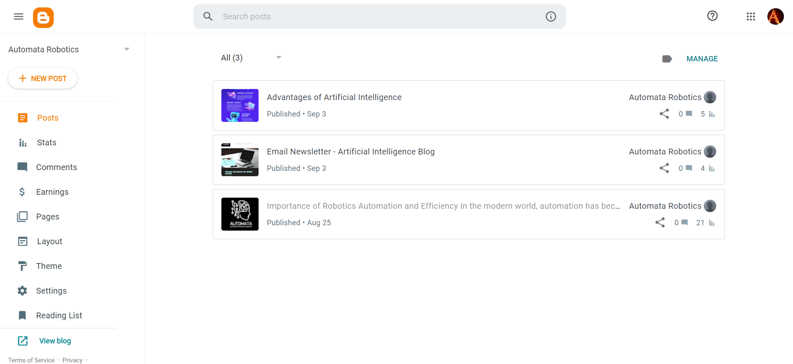

BLOG:

Blog url: <https://automatarobotics.blogspot.com/2023/08/importance-of-robotics-automation-and.html>



2. Create a New Facebook Business Page and post one social media poster for your brand.

* Create a Facebook Business Page:

Go to Facebook and log in to your personal account.

Click on the "+ Create" button in the top-right corner.

Select "Page" and choose the type of page you want to create .

Follow the on-screen instructions to fill in your business information, including the page name, category, and description.

* Customize Your Page:

Add a profile picture (usually your brand's logo).

Add a cover photo that represents your brand or a current promotion.

Fill in your "About" section with important business details.

* Create a Social Media Poster:

Use a graphic design tool like Adobe Spark, Canva, or even Facebook's built-in tools to create your social media poster.

Design the poster with your branding elements, such as colors, logos, and a clear message.

Include a visually appealing image or graphic.

* Post Your Social Media Poster:

Go to your Facebook Business Page.

Click on the "Create Post" button.

Upload the social media poster image you created.

Write a caption that complements the poster and includes relevant hashtags and mentions.

Choose the audience for your post (public, friends, specific groups, etc.).

Facebook page url : <https://www.facebook.com/AutomataRoboticss>

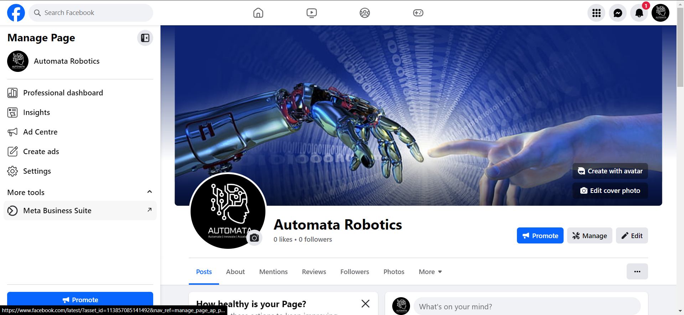

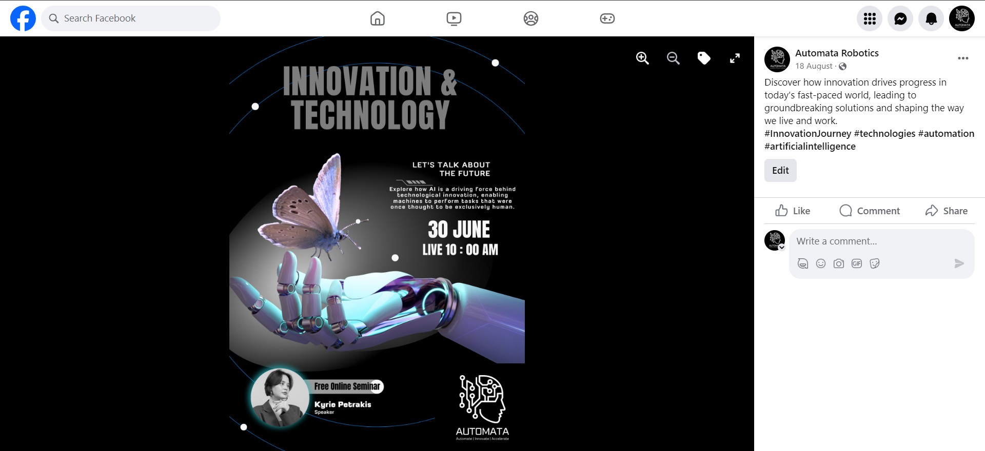

3. Create and design a social media advertisement poster using canva.

* Sign in or Sign up:

Go to Canva's website.

If you have an account, sign in. Otherwise, create a new account.

* Select the poster template:

On the Canva homepage, click on the "Create a design" button.

In the search bar, type "Social Media Advertisement Poster" and select an appropriate template.

* Choose a layout:

Browse through the available layouts on the left panel.

Select the one that best fits your advertisement's requirements.

* Customize your poster:

Click on the elements (text, images, etc.) that you want to change or modify.

Use the options in the toolbar at the top to edit the text, colors, fonts, and sizes.

Drag and drop to rearrange elements, or delete elements that you don't need.

* Add images and text:

Click on the "Uploads" tab on the left panel to upload your own images, or use Canva's built-in image library.

Drag and drop the images onto the template.

Click on the text boxes to add your own text. Customize the text according to your brand's message.

* Adjust the background:

If necessary, change the background color or image to complement your brand's identity.

* Include your logo:

Click on the "Uploads" tab to upload your company's logo.

Drag and drop the logo onto the poster and resize it as needed.

* Review and refine:

Check your design for any errors or inconsistencies.

Make necessary adjustments to ensure that the poster looks professional and visually appealing.



4. Create email newsletter design using MailChimp or canva tool.

* Sign in to Canva:

Go to the Canva website and sign in to your account.

* Select Email Newsletter Template:

In the search bar, type "Email Newsletter" and choose a template that suits your needs.

* Customize the Template:

Edit the template by changing the colors, adding your content, and uploading your images.

* Add and Edit Elements:

Use the drag-and-drop feature to add elements such as text, images, icons, and shapes. Adjust the size and position as necessary.

* Preview and Save:

Before finalizing, preview your design to ensure it appears as intended. Once satisfied, save your design.

